2023 REGISTRATION FORM
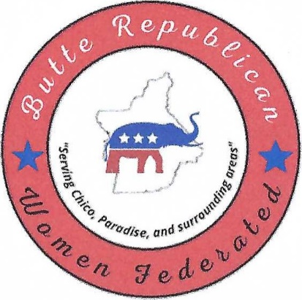

"When she speaks, her words are wise, and she gives instructions with kindness." Proverbs 31:26

TYPE OF MEMBERSHIP

MEMBER $50.00_____ ASSOCIATE $25 _____ CHECK # _____CASH _____ SQUARE ____DATE: _______

MAKE CHECKS PAYABLE TO: BCRWF

SEND TO: PO BOX 5439, CHICO CA 95927

NAME BIRTHDATE: _____/_____ (MONTH & DAY ONLY)

EMAIL_______________________________________ STREET ADDRESS____________________________

CITY/STATE: __________ ZIP:_________ HOME #: _________________CELL:_____________________
REGULAR MEMBER OF ANOTHER FEDERATED CLUB? YES: ___NO:_____NAME:__________________

MEMBERSHIP BENEFITS:
-Nine no-host luncheon meetings per year, featuring topical speakers, and/or Republican office holders or candidates addressing current issues. – Monthly newsletters and e-mails featuring the latest club information, Women's Federation events, Conservatives articles, legislative updates/alerts, and volunteer opportunities. -Membership in the California and National Women Federation. - Regular updates on local and national political activities and elections - Opportunities for seminars, Zoom meetings, and conferences to gain information and knowledge of principles and practices of the Republican Party - Information for election vote, fundraisers, and club-sponsored community service activities at a grassroot level.
INTERESTS:
Tell us in which areas you are interested in volunteering:
___President ____Executive BoardFirst Vice President in charge of speakers for Programs.
—SecondVice President in charge of Memberships___Newsletter___elections committee___fundraising___Telephone Tree___Website___
___Third Vice President in charge of ways and means. ___Fourth Vice President in charge of Campaign & Precinct Activities. ___Recording Secretary ___Communications Network Chair ___Voter Registration Treasurer ___Parliamentarian___Americanism___Publicity___Chaplain.___Sunshine.___Legislature
Follow us on:
butterepublicanwomenfederated.com
mailto:brwfca2022@gmail.com
PH #: 530-521-3707 Español: 305-951-0856
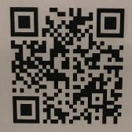
@brwfca Butte Republican Women Federated

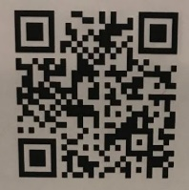

SCAN AND PAY FOR YOUR MEMBERSHIP HERE

